ICT167 Principle of Computer Science

Table of Contents

**1.** **Title** 3

**2. Requirements/Specification** 4

**3. User Guide** 5

**4. Structure/Design/Algorithm** 5

**5. Limitations** 5

**6. Testing** 5

# **1. Title**

**Student Management System Documentation:** Authored by Keith Neo Kai Si on March 28, 2024, the Student Management System Documentation provides an overview of the functionalities of the Java-Based Student Management System. The system is designed to handle student data through CSV files and comprises several Java files, including **CsvHandler.java**, **Client.java**, **Student.java**, **Student_Research.java**, **Student_Course.java**, **Unit.java**, **Unit_Course.java**, and **Research.java**. Its core objectives include efficiently loading student information from **student.csv**, adding marks from **student_marks.csv**, student removal, information display, and exporting organized student data to a CSV file. Employing Java’s object-oriented programming principles, such as inheritance and polymorphism, the system effectively models various student types and their enrolment in different units. Furthermore, the documentation elaborates on Java’s file-handling capabilities, illustrating the system’s CSV file reading and writing processes for sustained data integrity. This comprehensive guide serves as a valuable reference for developers seeking to implement or enhance student management systems using Java.

# **2. Requirements/Specification**

The Student Management System is created to effectively handle and manage student information, such as importing student details from CSV files, adding marks to students, deleting students, displaying student information, and exporting organized student data back to a CSV file. The system assumes that the input CSV files are correctly formatted, with student.csv containing student type, name, and ID and student_marks.csv containing student IDs followed by marks or course and marks. The desired output is a sorted list of students with their marks included, which can be saved to a new CSV file.

The system’s design utilizes fundamental object-oriented programming concepts:

**1. Inheritance**: The Student class acts as the base class, with Student_Research and Student_Course extending it to represent different types of students. This allows for reusing code and adding specific attributes and methods for research and course students.

**2. Polymorphism**: The reportGrade method in both Student_Research and Student_Course classes overrides the reportGrade method in the Student class, showcasing polymorphism. This enables different implementations of the method based on the student type.

**3. Dynamic Binding**: The system employs dynamic binding to determine the appropriate method to call at runtime. For instance, when calling reportGrade on a student object, the JVM decides whether to call the Student, Student_Research, or Student_Course implementation based on the actual type of the student object.

**4. Sorting Algorithm**: The system utilizes an insertion sort algorithm to arrange students by their IDs. This is done using the sortStudents method, which sorts the list of students in ascending order of their IDs.

**5. Handling CSV Files**: The system uses Java’s built-in Scanner class to read from CSV files. It reads each line of the student_marks.csv file, separates the line into components based on the comma separator, and processes the data accordingly. For writing to a CSV file, the system uses PrintWriter to output the sorted list of students to a new file.

This documentation presents a comprehensive overview of the requirements, specifications, and implementation details of the Student Management System, ensuring that developers and users comprehend the system’s functionality and how it fulfills the specified needs.

# **3. User Guide**

**Compilation and Execution:**

1. **IDE:** [Eclipse IDE 2024-03](https://www.eclipse.org/downloads/packages/installer) is used for this program.

2. **Compilation:** To begin compiling the Java program in Eclipse, first open the Eclipse IDE on your computer. After launching Eclipse, navigate to the top left corner and click “File.” Select " New " from the dropdown menu and click “Java Project.” In the “New Java Project” menu, enter a name for the project, such as “Assignment_2”. Make sure to deselect the “Use default location” option, and then navigate to the folder where the Java source codes are stored, “ICT167-Assignment-2-Keith-Neo-35107628”. Inside this folder, find the “java_codes” folder and select it as the location for the new project. Ensure that the “Create module-info.java file” option is not checked. Once all the settings are configured, click “Finish” to finalize the process.

3. **Execution:** Navigate to the Package Explorer panel after successfully creating the Java project in Eclipse. Right-click on the Java project that was made. From the dropdown menu that appears, select “Run As” and then choose “Java Application.” This action will execute the Java program within the Eclipse environment.

**Using the Program:**

* When the program is launched, users will receive a welcome message containing student information, indicating the current student profile that developed the program. After the student information, users will be presented with the program's main menu, providing various options for interacting with student data and carrying out different tasks.

* If the user enters nothing, letters, or unknown options, the system will display “Invalid input. Try again.” Or “Unknown choice. Try again.” This will prompt the user to retry the input.

* If option 1 is selected, the program will exit and display a farewell message

* If option 2 is selected, the program will dynamically aggregate the marks and units (for course students). The program will display “Student <count> marks loaded” for each student, dynamically loading the marks based on the student type from student_marks.csv. It’s important to note that marks for course students contain a unit, while marks for research students do not include a unit. Upon completion, the program will display “Student marks loaded,” indicating that all the student marks have been successfully loaded.

* If option 3 is chosen, the program will ask the user to input a student ID for deletion. If the user enters nothing, the program will exit this option and return to the main menu. If the user enters letters, the program will display “Invalid ID. Try again.” The program will attempt to locate the student if a valid student ID is entered. If the student is found, the program will display “Student found.” And present a confirmation option to the user. If the student is not found, the program will display “Student not found. Try again.” And prompt the user for another student ID.

Once the student is found and the user is at the confirmation menu, selecting “yes” or “y” (not case-sensitive) will result in the program removing everything related to the student and displaying “Student removed.” Choosing “no” or “n” will display “Student not removed.” After this, the program will display the main menu.

* If option 4 is chosen, the program will display each student's type, full name, and student number. If option 2 (Add marks from file) is previously selected, resulting in the student marks being loaded, the program will display the Unit ID for course students and the string “Has Unit” for research students.

* If option 5 is chosen, the program will show the number, of course, students who scored equal to or higher than the average, as well as the number of course students with scores lower than the average. The program will only display these numbers if option 2(Add marks from file) was previously selected. If option 2 was not previously selected, the program will display 0 for each count.

* If option 6 is chosen, the user will be asked to enter a student ID to view the student report. If the user enters a letter, an error message will be displayed, prompting the user to enter the student ID again. Upon entering a valid student ID, the program will attempt to find the student with the given ID. If the student is not found, the program will prompt “Student not found. Try again” and ask the user for the student ID again. If the student is found, the program will display the student's information using the reportGrade() function. However, if option 2 (Add marks from file) was not previously selected, the program will display “Student marks not loaded” and return to the main menu.

* If option 7 is chosen, the program will use the insertion sort algorithm to sort the student array list based on the student’s IDs. Upon completion of the sorting process, the program will display “Student sorted.”

* If option 8 is chosen, the student array list will only be saved if option 7 was previously selected to sort the students in ascending order. If the student array list is not sorted, the program will display “Student not sorted” and return to the main menu. If the student array list is sorted, the program will indicate that the sorted student array list has been saved to “csv_files/sorted_students.csv.”

**4. Structure/Design/Algorithm**

**UML for the Client program**

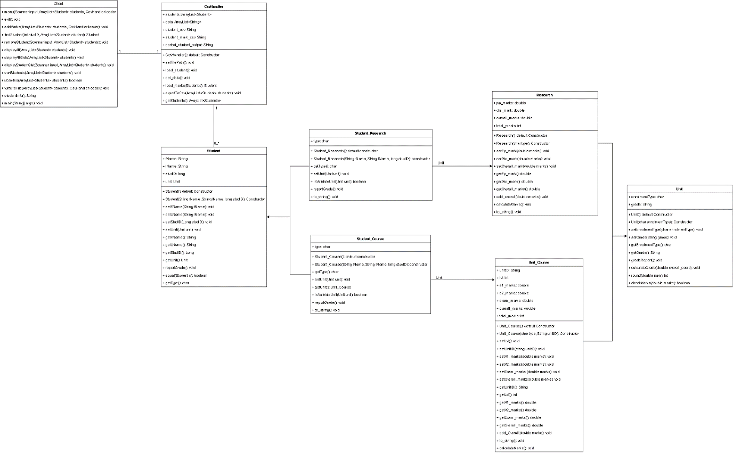

**Structure chart for the Client program**

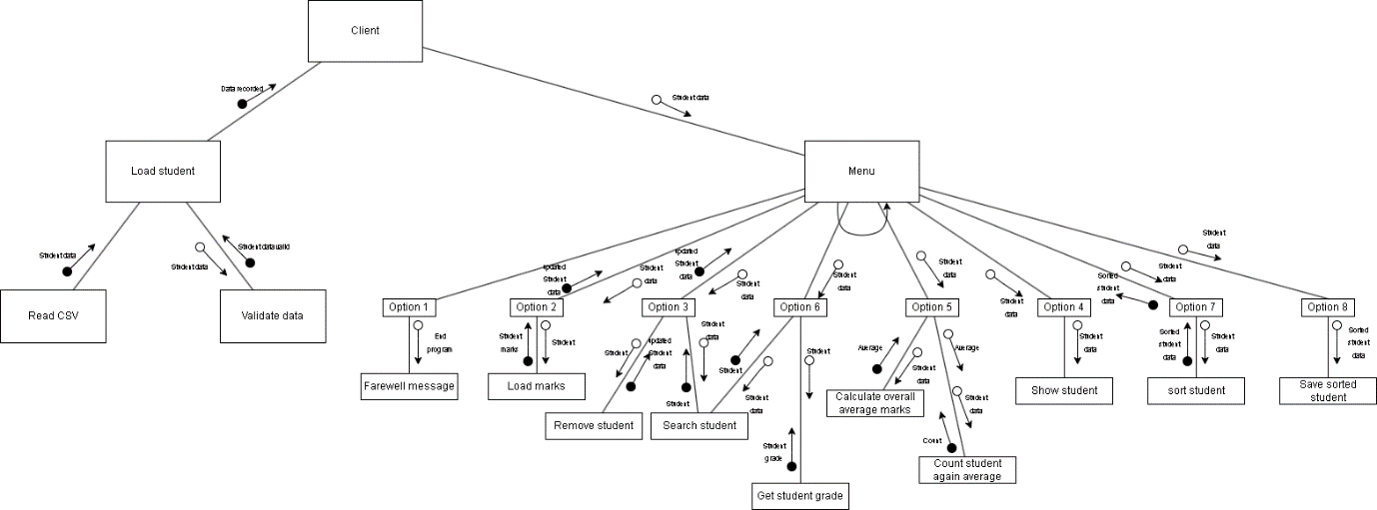

**Student Class**

The Student class serves as the base class for all students in the system. It encapsulates the basic attributes of a student, such as first name, last name, student ID, and a reference to a Unit object. The class provides constructors for creating a student with default values or specific values, getter and setter methods for accessing and modifying these attributes, and a reoportGrade() method that prints a default message indicating no grade is available. The equal method checks if two Student objects have the same student ID, and the getType() method returns a default character “N,” indicating a generic student type.

**Student_Course Class**

The Student_Course class extends the Student class, indicating that it is a specific type of student. It introduces a new attribute type with a default value of ‘C,’ representing a course student. The class overrides the getType() method to return this specific type. It also overrides the setUnit() method to validate that the unit being set is an instance of Unit_Course, ensuring that only course units can be associated with course students. The reportGrade() method in this class prints detailed information about the student, including their type, name, student number, unit ID, overall marks, and final grade if a course unit is associated. The to_string() method provides a string representation of the student’s information, including whether they have an associated course unit.

**Student_Research Class**

Similarly, the Student_Research class extends the Student class, representing a research student. It introduces a type attribute with a default value of ‘R,’ indicating a research student. The getType() method is overridden to return this specific type. The setUnit() method is overridden to validate that the unit being set is an instance of Research, ensuring that only research units can be associated with research students. The reportGrade() method prints detailed information about the student, including their type, name, student number, overall marks, and final grade, if a research unit is associated. The to_string() method provides a string representation of the student's information, including whether they have a research unit associated with it.

**Unit Class**

The Unit class represents a generic unit of study or course in which a student can enroll. It encapsulates the basic attributes of a unit, such as the enrolment type and grade. The enrolment type is a character that indicates the type of enrolment (e.g., ‘N’ for not enrolled, ‘C’ for course, ‘R’ for research). The grade is a string that holds the unit's grade, with a default value of “NA,” indicating that the grade is unavailable. The class provides constructors for creating a unit with default or specific enrolment type values. It also includes getter and setter methods for the enrolment type and grade. The gradeReport() method prints the unit's grade with a special message if the grade is unavailable. The calculateGrade() method calculates the grade based on an overall score, assigning a letter grade based on the score’s range. The checkMarks() method validates that the marks are within the acceptable range of 0 to 100.

|  |  |  |  |
| --- | --- | --- | --- |
| Pseudocode Explanation: calculateGrade() | | | |
| 1. | **Function** calculateGrade(overall_score) | | |
| 2. |  | **IF** overall_score is not a valid number (e.g., not within 0 to 100) | |
| 3. |  |  | Return “Invalid score” |
| 4. |  | **END IF** | |
| 5. |  |  | |
| 6. |  | **IF** overall_score >= 80 | |
| 7. |  |  | **SET** grade to “HD” (High Distinction) |
| 8. |  | **ELSE IF** overall_score >= 70 | |
| 9. |  |  | **SET** grade to “D” (Distinction) |
| 10. |  | **ELSE IF** overall_score >= 60 | |
| 11. |  |  | **SET** grade to “C” (Credit) |
| 12. |  | **ELSE IF** overall_score >= 50 | |
| 13. |  |  | **SET** grade to “P” (Pass) |
| 14. |  | **ELSE** | |
| 15. |  |  | **SET** grade to “N” (No grade) |
| 16. |  | **END IF** | |
| 17. |  | **RETURN grade** | |
| 18. | **END FUNCTION** | | |

**Unit_Course Class**

The Unit_Course class extends the Unit class, indicating that it represents a course unit. It introduces additional attributes specific to course units, such as the unit ID, level, and marks for assignments and exams. The class provides constructors for creating a course unit with default values or specific values for the type and unit ID. It also includes methods for setting and getting these additional attributes. The setLvl() method extracts the level from the unit ID, which is assumed to be the fourth character of the ID. The setUnitID() method the unit ID and recalculates the level. The setA1_marks(), setA2_marks(), and setExam_marks() methods allow setting marks for assignments and exams, updating the overall marks, and recalculating the grade. The calculateMarks() method calculates the grade based on the overall marks and updates the grade accordingly. The to_string() method provides a string representation of the course unit’s information.

|  |  |  |  |
| --- | --- | --- | --- |
| Pseudocode Explanation: calculateMarks() for Unit_Course class | | | |
| 1. | **Function** calculateMarks() | | |
| 2. |  | **IF** a1_marks, a2_marks, and exam_marks are all valid numbers (0 to 100) | |
| 3. |  |  | calculate overall_marks by summing a1_marks, a2_marks, and exam_marks |
| 4. |  |  | Calculate grade based on overall_marks |
| 5. |  |  | Updates grade attributes with the calculated grade |
| 6. |  | **End If** | |
| 7. | **End Function** | | |

**Research Class**

The Research class also extends the Unit class, representing a research unit. It introduces attributes specific to research units, such as proposal marks, dissertation marks, and overall marks. The class provides constructors for creating a research unit with default or particular values for the type. It also includes methods for setting and getting these additional attributes. The setPp_mark(), setDis_mark(), and setOverall_mark() methods allow setting marks for the proposal, dissertation, and overall research project, updating the overall marks and recalculating the grade. The calculateMarks method calculates the grade based on the overall marks and updates the grader accordingly. The to_string() method provides a string representation of the research unit’s information.

|  |  |  |  |
| --- | --- | --- | --- |
| Pseudocode Explanation: calculateMarks() for Research class | | | |
| 1. | **Function** calculateMarks() | | |
| 2. |  | **IF** pp_mark, dis_mark are valid numbers (0 to 100) | |
| 3. |  |  | calculate overall_marks by summing pp_mark and dis_mark |
| 4. |  |  | Calculate grade based on overall_marks |
| 5. |  |  | Updates grade attributes with the calculated grade |
| 6. |  | **End If** | |
| 7. | **End Function** | | |

**CsvHandler Class**

The CsvHandler class in Java is designed to manage student data from CSV files, including loading student information, processing marks, and exporting sorted student data to a CSV file. It supports different types of students, such as Student_Course and Student_Research, by distinguishing them based on a prefix in the CSV file. Upon initialization, the class set file paths for student data, marks, and the output file for sorted students. It then loads student data, where each line from the student CSV file is read, and either a Student_Course or Student_Research object is created based on the prefix, adding them to an ArrayList of students.

|  |  |  |  |  |  |
| --- | --- | --- | --- | --- | --- |
| Pseudocode Explanation: load_student() | | | | | |
| 1. | **Function** load_student() | | | | |
| 2. |  | **Try** | | | |
| 3. |  |  | **Open** fileReader for reading from student_csv file | | |
| 4. |  |  | **While** there are more lines in the file | | |
| 5. |  |  |  | **Read** the next line from the file | |
| 6. |  |  |  | **Split** the line into an array of strings using comma as the delimiter | |
| 7. |  |  |  | **If** the first element of the array is “C” | |
| 8. |  |  |  |  | **Create** a new Student_Course object with the second, third, and fourth element of the array |
| 9. |  |  |  |  | **Add** the new Student_Course object to the student's ArrayList |
| 10. |  |  |  | **Else** If the first element of the array is “R” | |
| 11. |  |  |  |  | **Create** a new Student_Research object with the second, third, and fourth elements of the array |
| 12. |  |  |  |  | **Add** the new Student_Research object to the student's ArrayList |
| 13. |  |  | **End** **While** | | |
| 14. |  |  | **Close** fileReader | | |
| 15. |  | **Catch** any **exception** | | | |
| 16. |  |  | **Print** an error message | | |
| 17. |  | **End** **Try** | | | |
| 18. | **End Function** | | | | |

The set_data() method loads the student marks from another CSV file into an ArrayList of data strings. The load_marks() method iterates through the marks data to find and set marks for each student based on their ID, supporting different types of students by checking the instance of the student object and setting the marks accordingly.

Finally, the exportToCsv() method writes the sorted list of student objects back to a CSV file, formatting each student’s information into a string and writing it to the output file.

# **5. Limitations**

# **6. Testing**